**BASIC REDUX**

Action is dispatched from JS to State which Uses Reducers to determine new state

action: jsobject with type in it where type is a string telling what aciton has happened

actionCreator: function which returns an object

actionCreator with payload example:

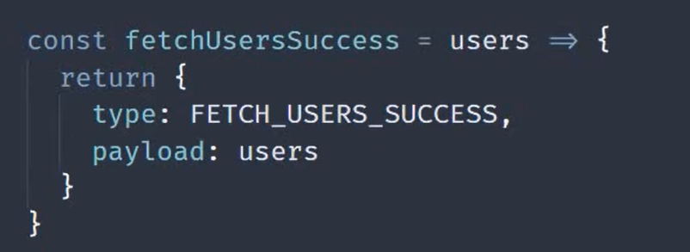

reducer: function which accepts previous state and action as arguements to give newstate

i.e return new object which holds new state details(only ones need to be modified)

store:

* allow access to state using "getState()"
* provide dispatch method to accept action and hence go forward in changing state
* register listener or functions through subsvribe(listener) where listener is a function which is executed any time state in the store changes
* unsubscribe is return of subscribe function

redux Functions=>

* redux.createStore(reducer,)=> to create store
* store.getState()=> to obtain store
* sotre.subscribe( () => {})=> subscription to function to be executed on store change
* store.dispatch(actionCreator())=>dispatch an action
* redux.combineReducer({key1:reducer1,key2:reducer2})=> to combine reducers as having multiple reducers is necessary to ensure non overlapping
* redux.applyMiddleWare() => used to apply an middleware to store such as redux logger. Should be passed as second argument to createStore=> redux.createStore(reducer,redux.applyMiddleWare(imported/required package))
* redux.bindActionCreators=> actions = ({actionCreator},store.dispatch) => allows to call actions.actionCreator() instead of dispatch(actionCreator)

Different Reducers with different intialState

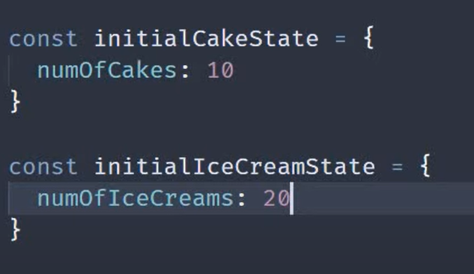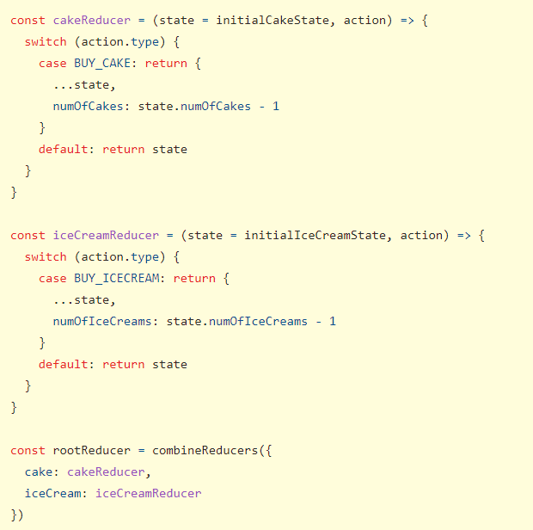

Note:while combinreducer, while accessing store to get that state we need to specify store.key1.value

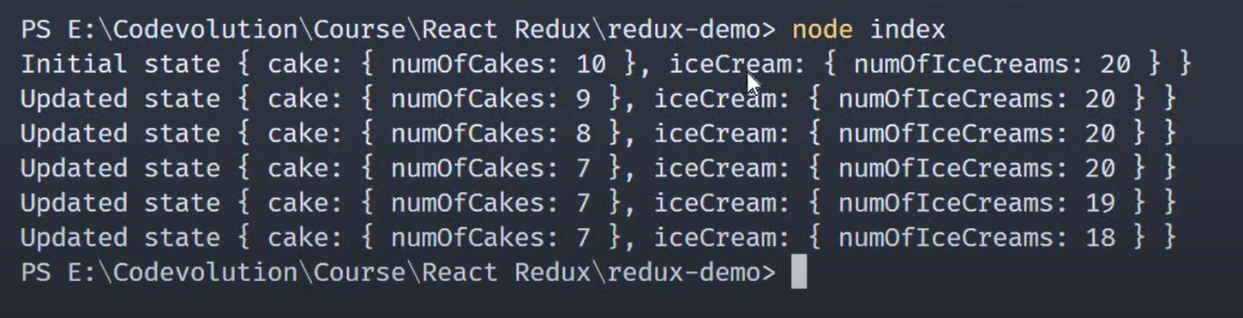

NOTE WHILE USING MULTIPLE REDUCERS

In the below example iceCreamReducer will also reduce the number of ice creams if cake is orderd even though we don’t want it to

A "slice" is a collection of Redux reducer logic and actions for a single feature in your app,

thunkMiddleware=> actionCreator can return a function instead of normal action object=>enables to perform asynchronous tasks(such as API calls) while dispatching regular tasks

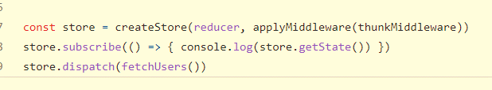

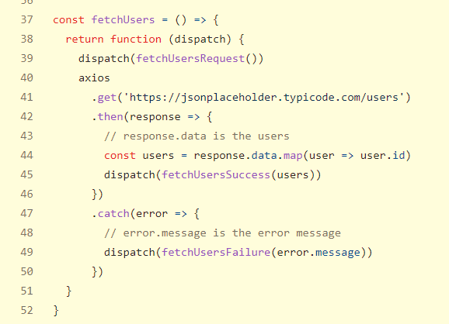

Immer package

Does equivalent changes as show below. Draft is a copy of state. Used to handle immutable state which is to be returned in reducers. The line of return produce and its function equivalent is shown as commented.



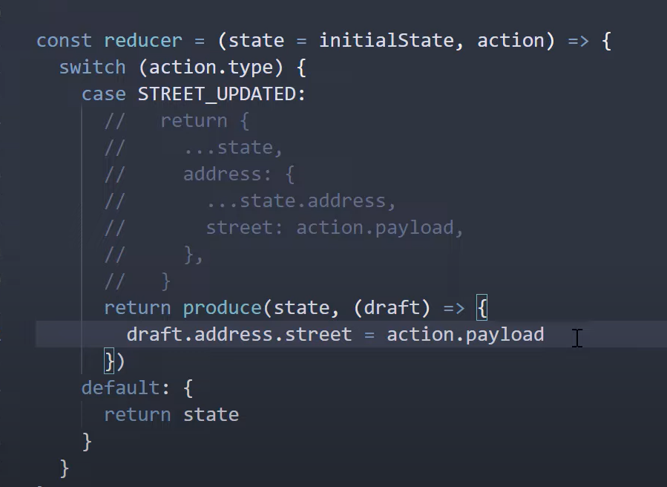

**REACT REDUX**

Npm install redux react-redux

ActionCreators Example

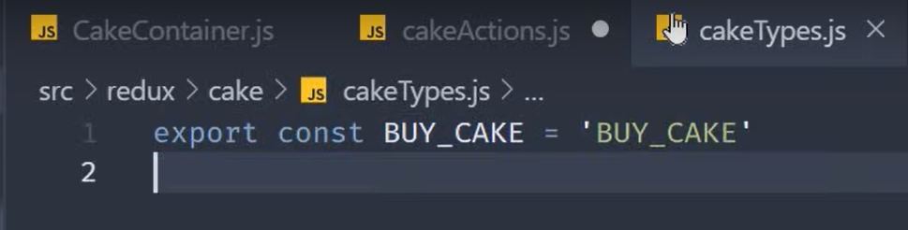

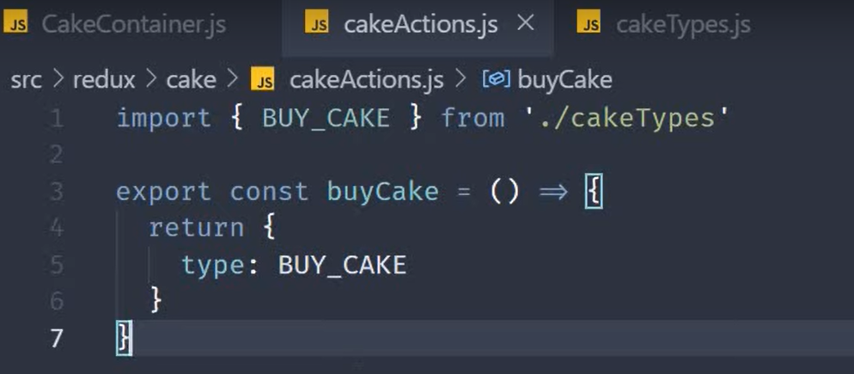

Reducer example

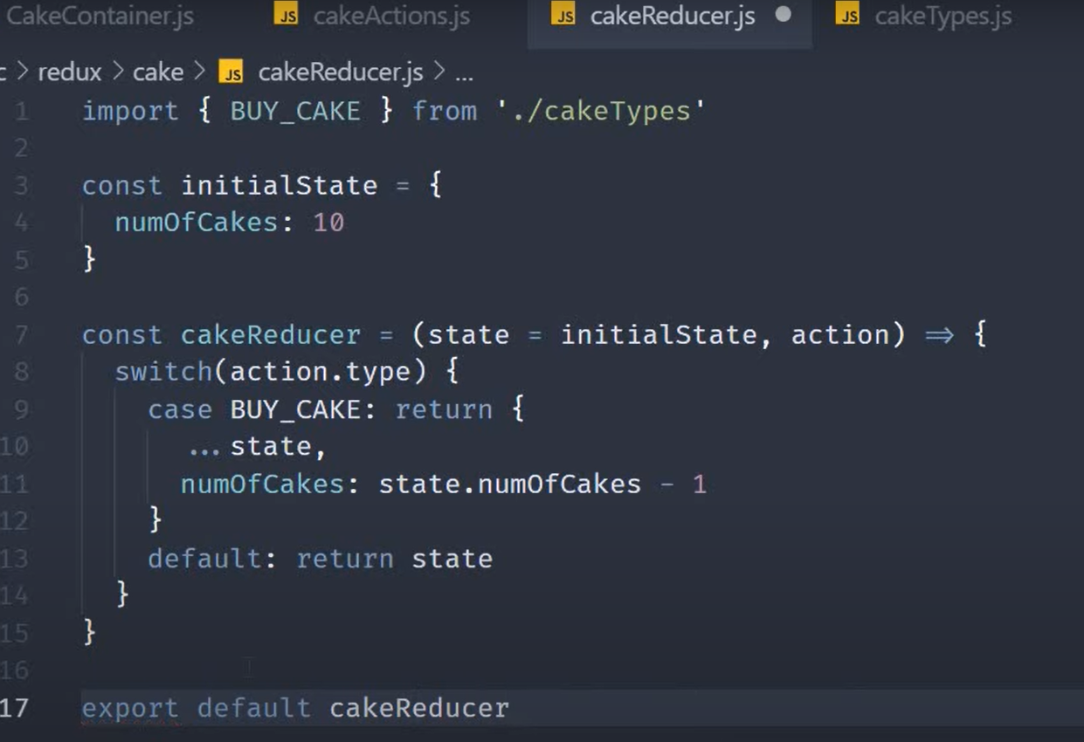

Store:

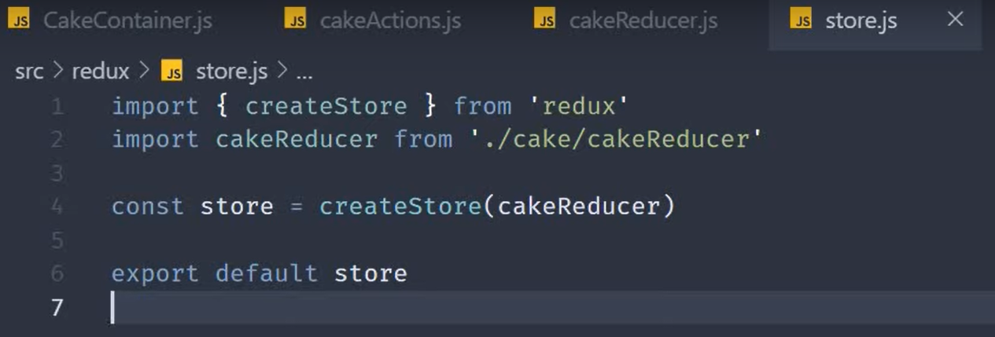

Now for consuming this store we use Provider from react-redux

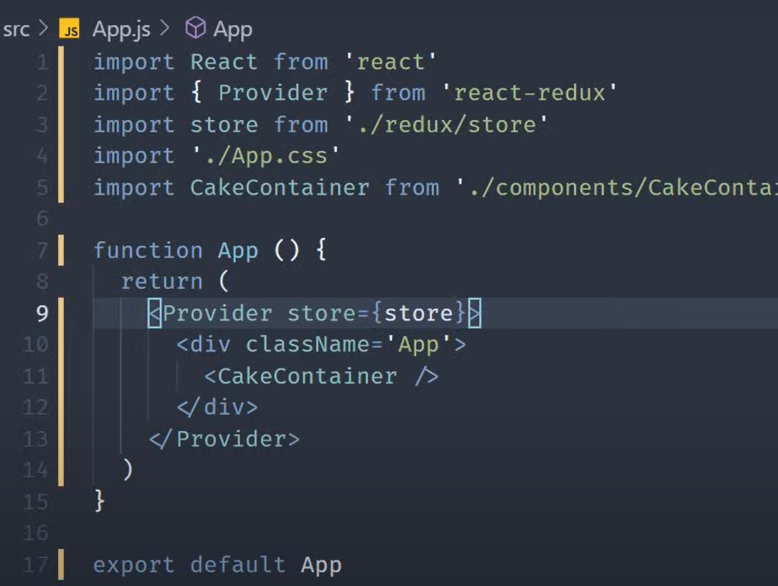

Selectors are functions that return state information to be consumed by redux component. Example(Note not exactly a selector but gives an idea)

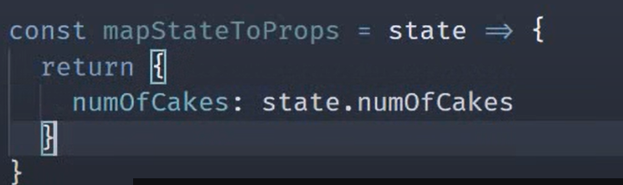

Incase the parent component has some props which is required to be read and hence give a logic we use the ownProps

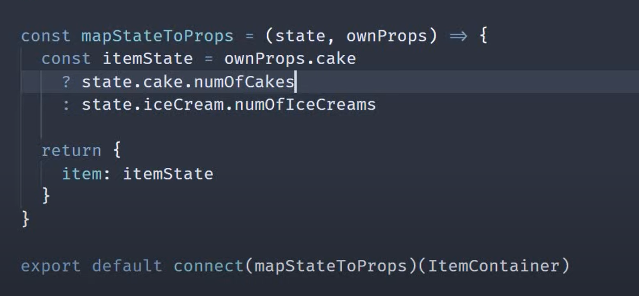

Dispatch Connection

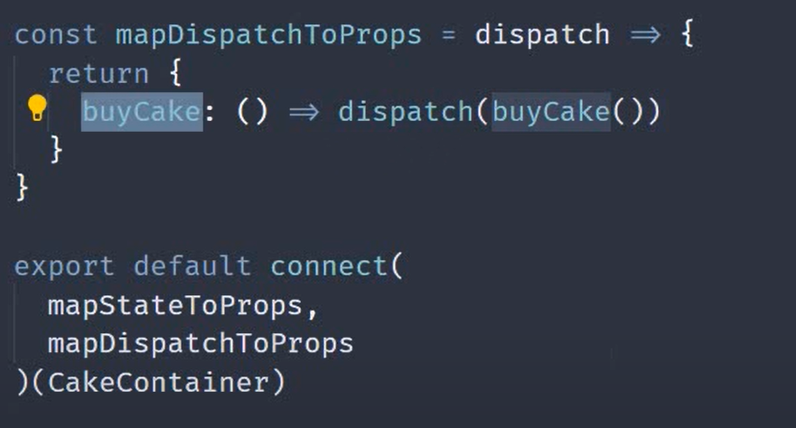

Incase the parent component has some props which is required to be read and hence give a logic we use the ownProps

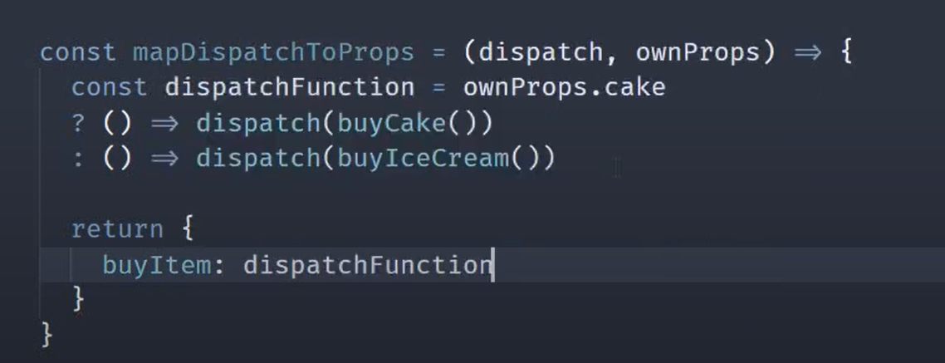

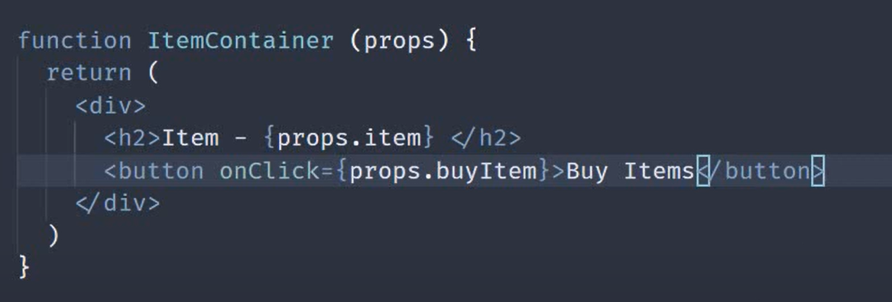

Once Selector and Dispatch is connected using connect from react-redux. The CakeContainer Component would receiver props with those functions as shown below

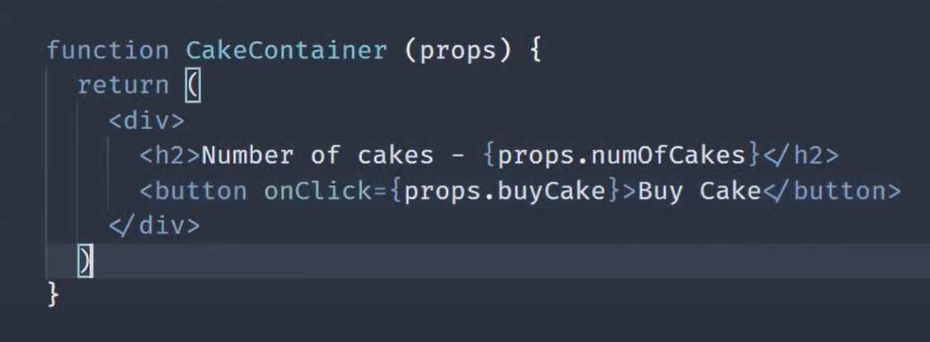

Dispatch with payload

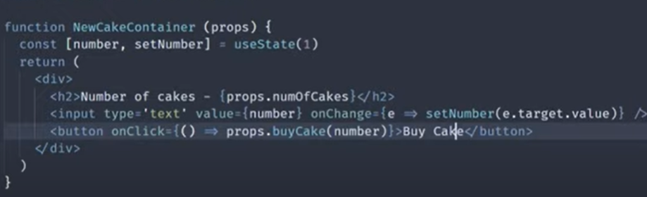

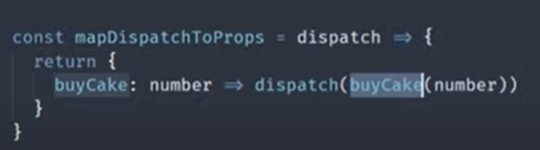

This connection between selector and dispatch to component can be done using hooks also

useSelector Hook:

returns variable which contains value of a certain state value. In below example numof cakes

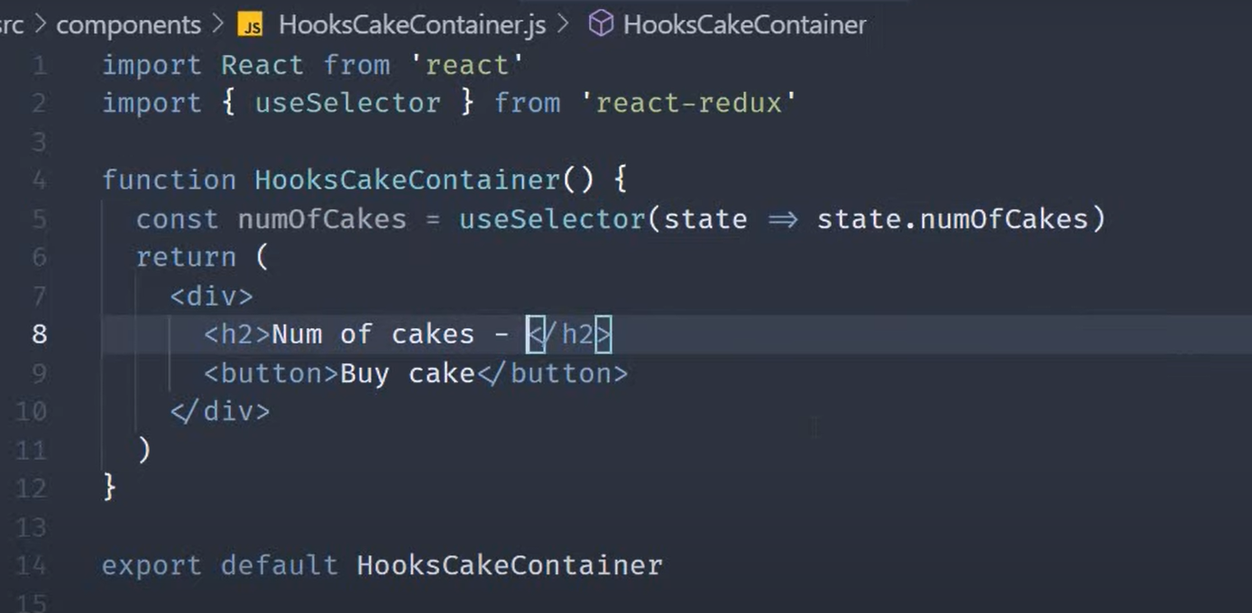

useDispatch hook:

returns variable that can be used to call dispatch of various actions

Note:Import ActionCreators to specific Component e.g. buyCake()

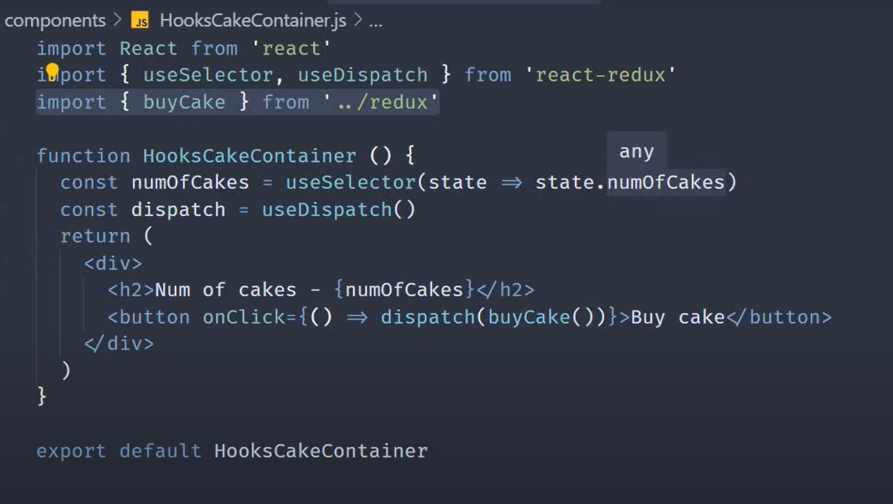

CombineReducers in REACT

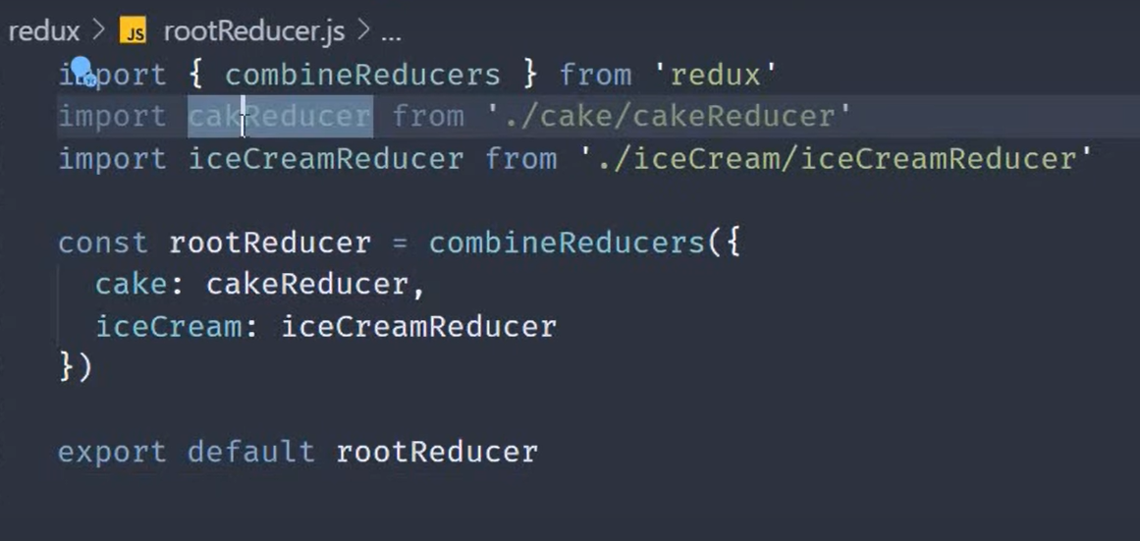

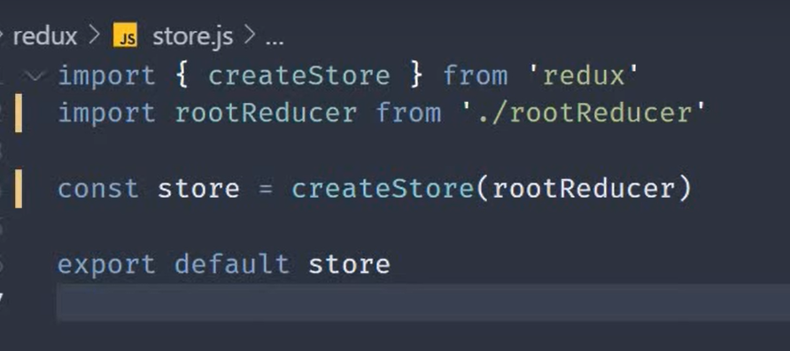

NOTE WHILE USING MULTIPLE REDUCERS

In the below example iceCreamReducer will also reduce the number of ice creams if cake is orderd even though we don’t want it to

EACH state.xyz would become state.key_of_child_reducer.xyz in Components(SELECTORS(mapStateotProps) or useSelector)

Eg state.numofcakes => state.cake.numofcakes

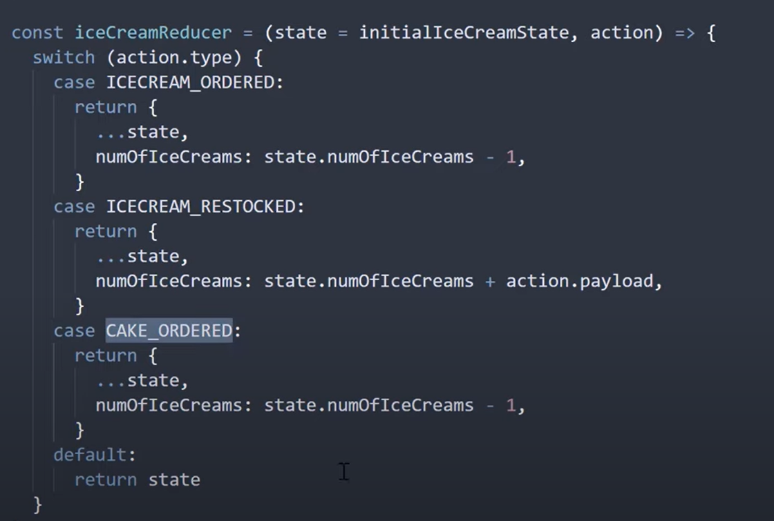

Middleware in React-redux

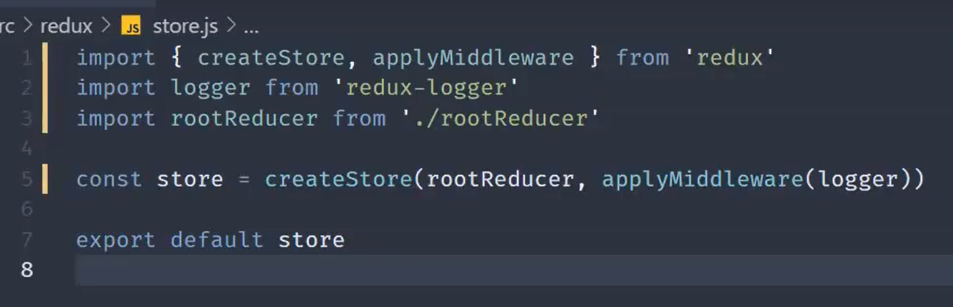

Redux DevTools

Install extension for chrome and then use npm install –save redux-devtools-extension and import it into project as shown below. Can help in creating dispatchs without button and view what each action does etc.

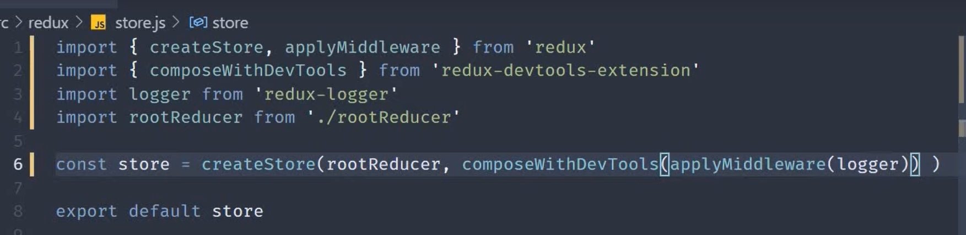

Getting Payload and using it

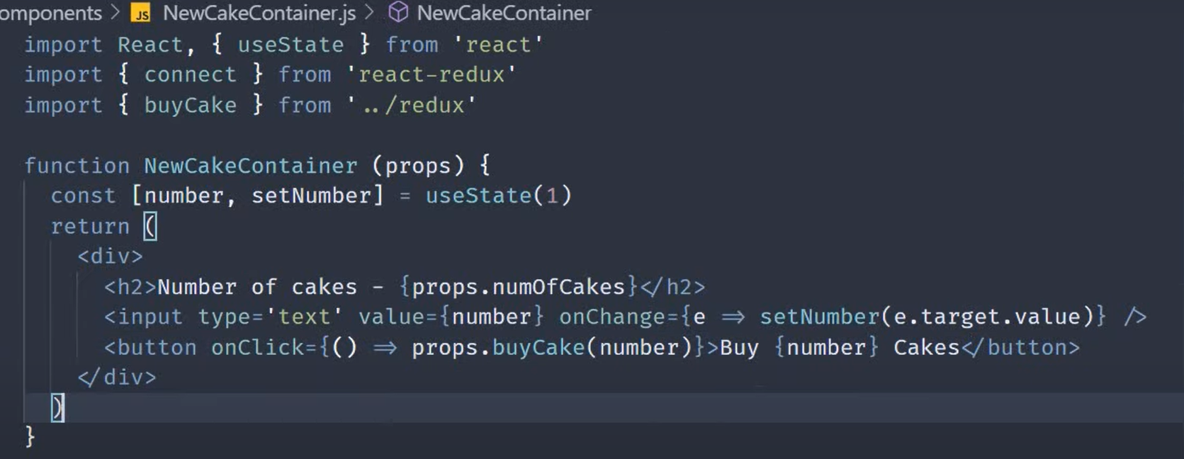

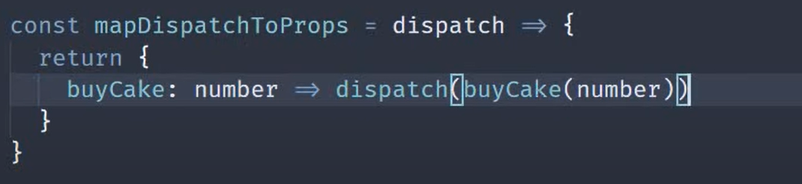

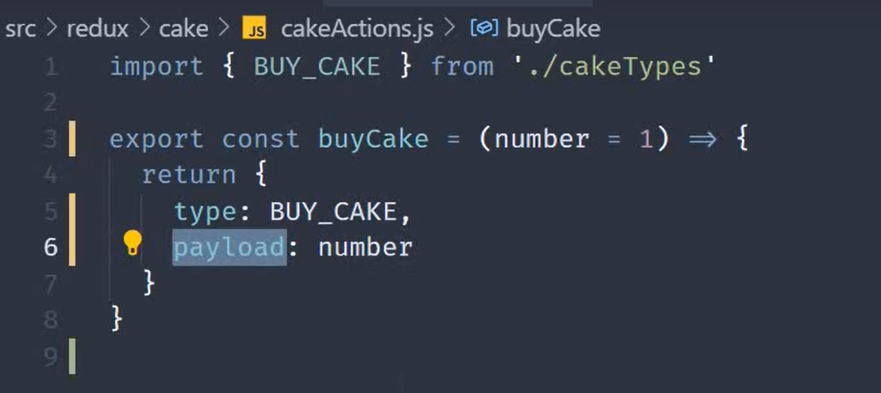

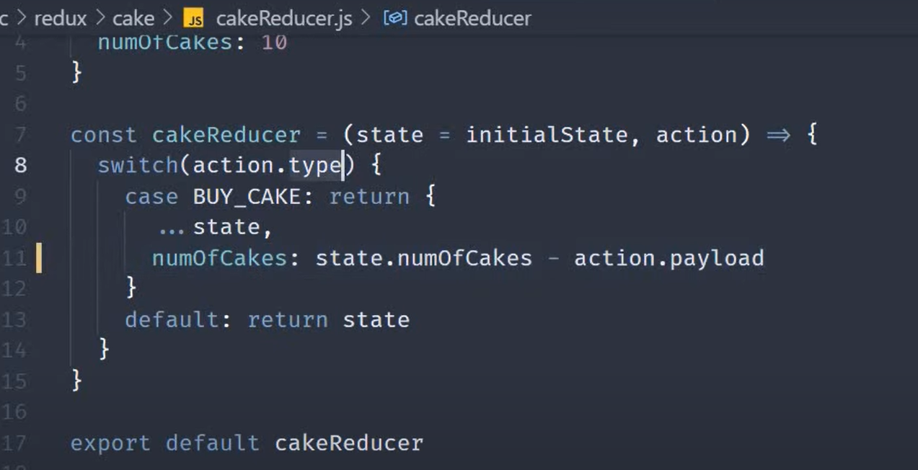

REDUX THUNK

The thunk middle ware is used for writing functions with logic inside that can interact with a Redux store's dispatch and getState methods.

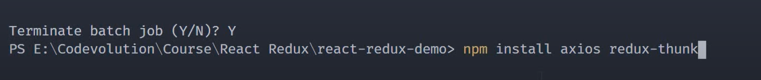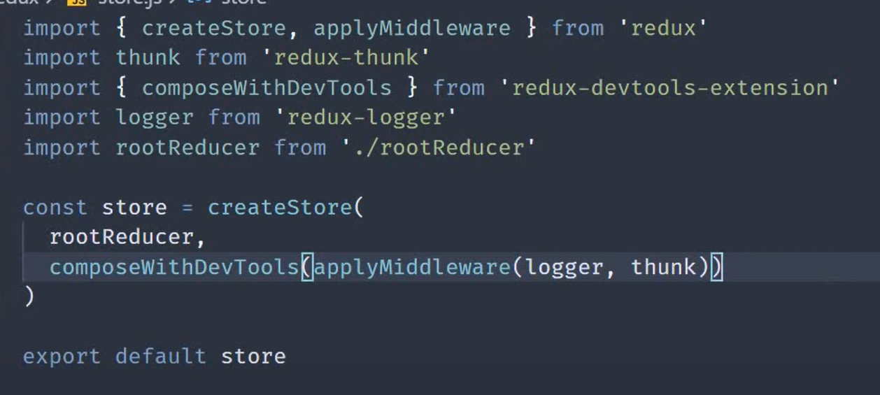

Writing function in action(to get api call and use dispatch)

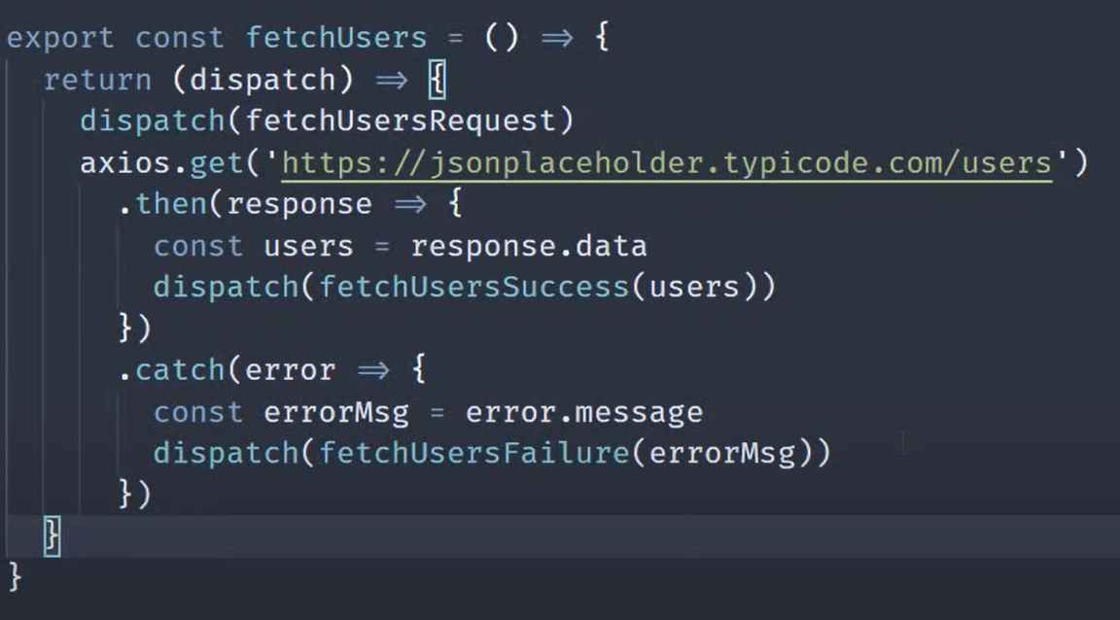

**REDUX TOOLKIT**

Slices

Takes care of everything (actionCreators,reducer logic, usage of immutable objects) under the hood.

In the below example

* reducer would do whatever we would do with switch statement automatically for each function
* would automatically create actionCreators as required behind the scenes with the name as function keys given under reducers object

We can then export these reducers(as default) and actions(as named export) for usage in the store

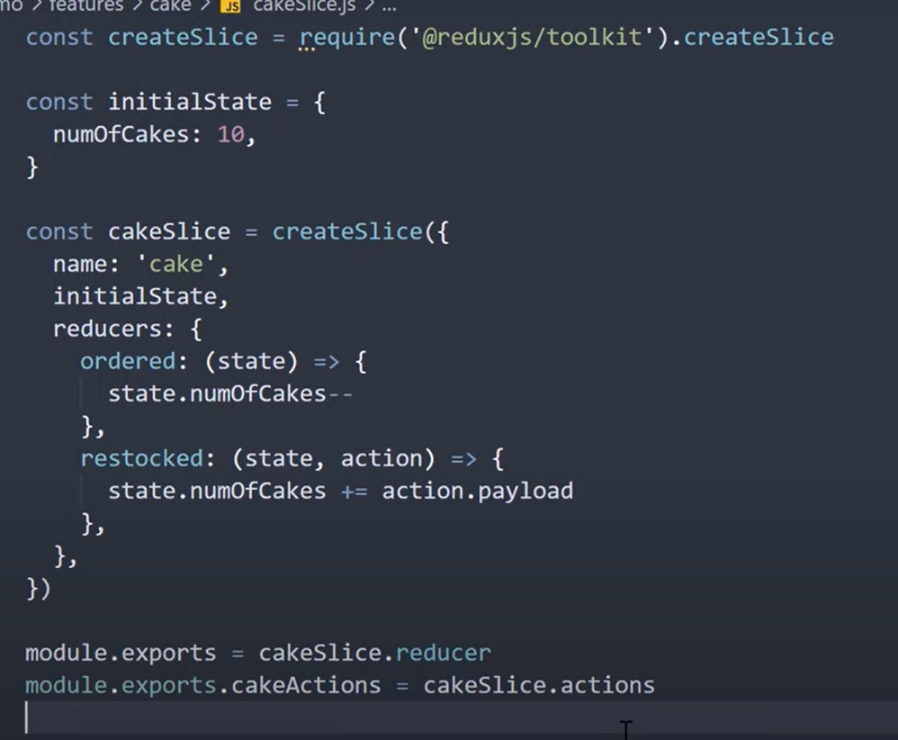

Store

Attach the reducers

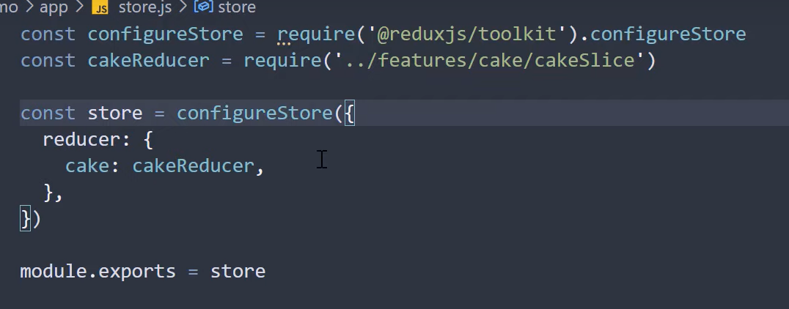

No need to specifically combine reducers

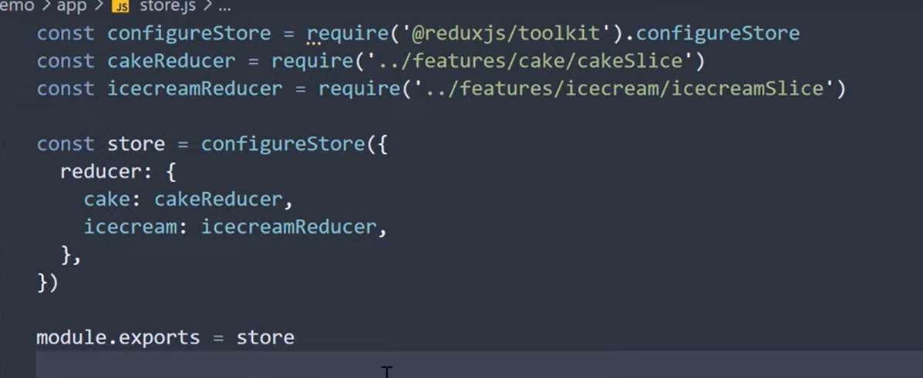

Dispatching Actions

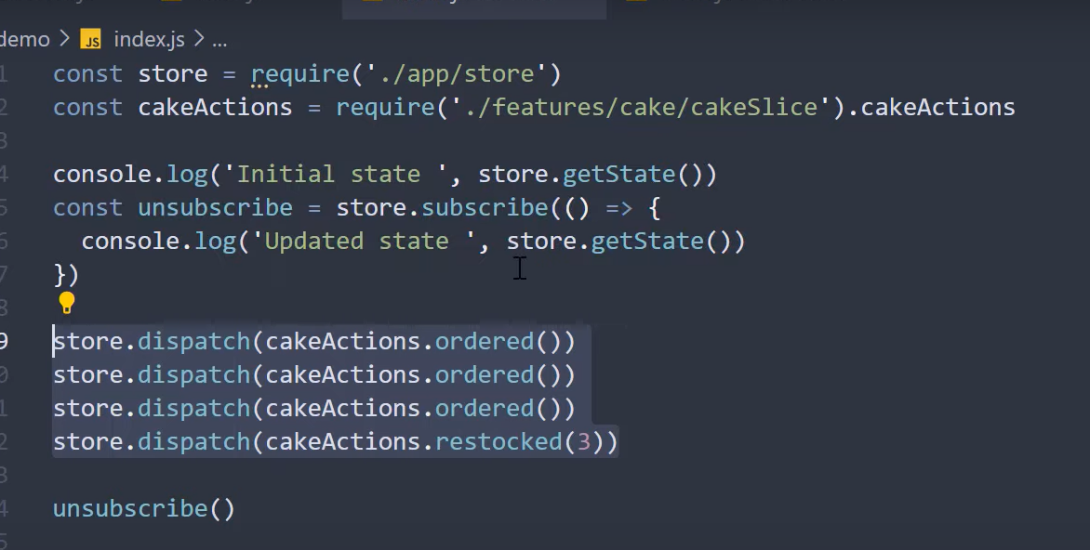

Applying Middleware (Logger Example)

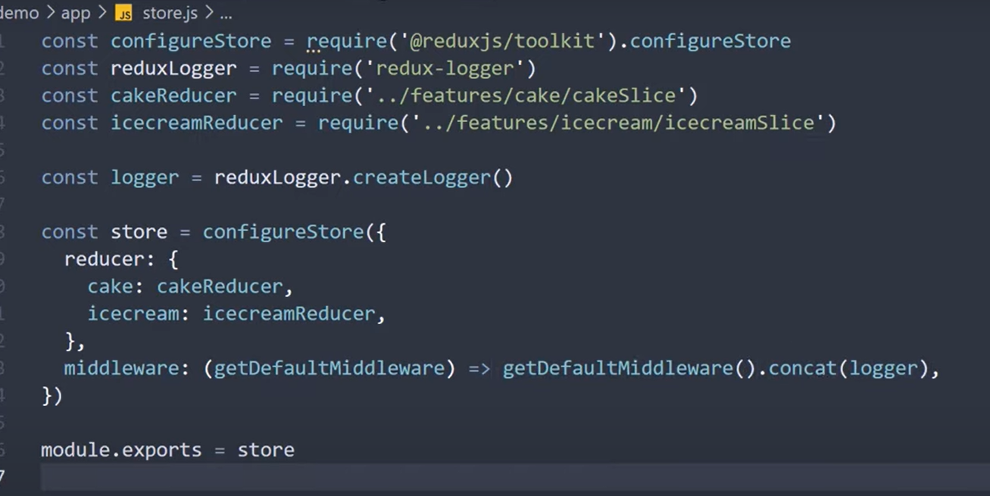

Adding ExtraReducers

to enable if we still want to do some change in current reducer for some other action in other Reducer. Action is for when cakeAction ordered.(Same as reducer name)

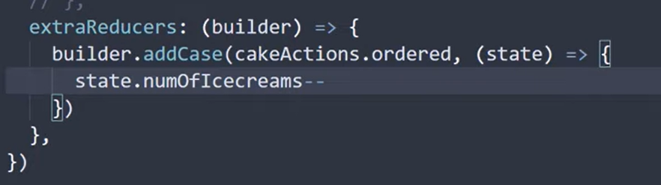

Thunk Middleware Equivalent (inbuilt)

Action type as first argument (usually: “name of reducer/actionName”), Callback is second Function.

* Pending is for when async is still taking place.
* Fullfilled is when successful
* Rejected is for error

The create asyncthunk output should be added as extraReducers

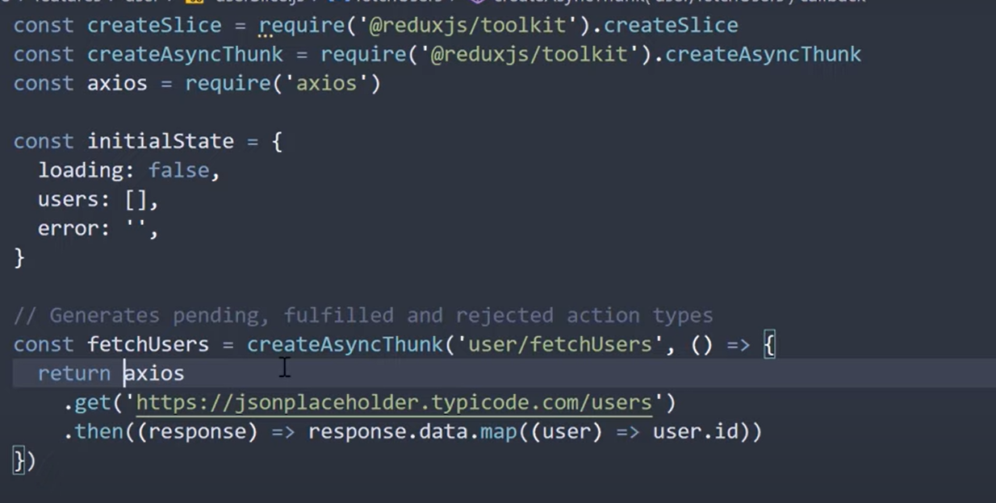

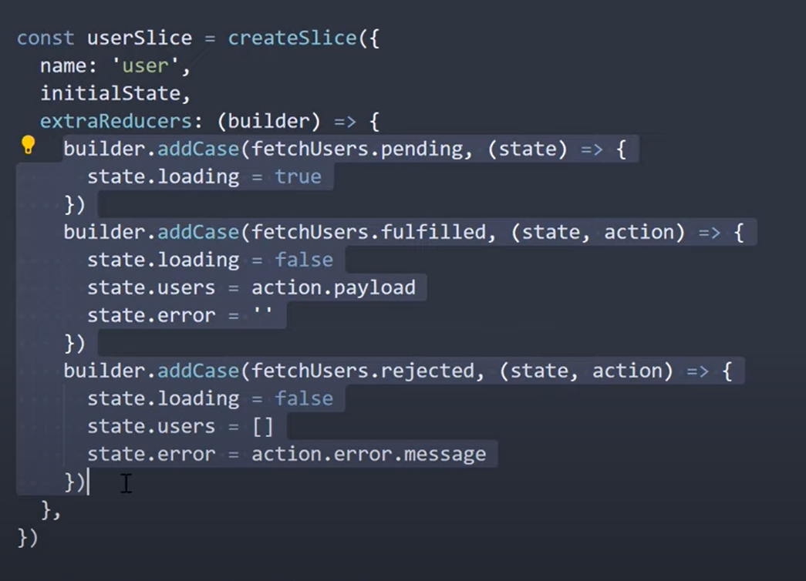

**REACT-REDUX TOOLKIT**

Import the necessary modules instead of require.

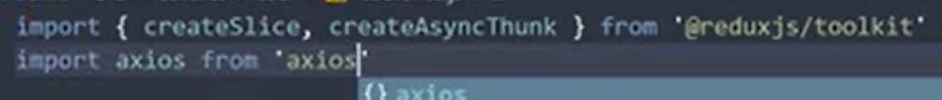

For export use default export (for reducer) and export const{actionCreatorName} (for action creators)

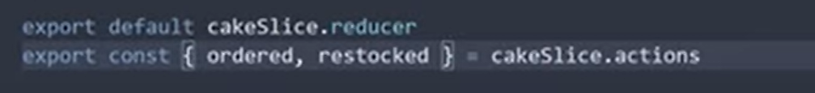

Giving Provider (Mnadotyr)  
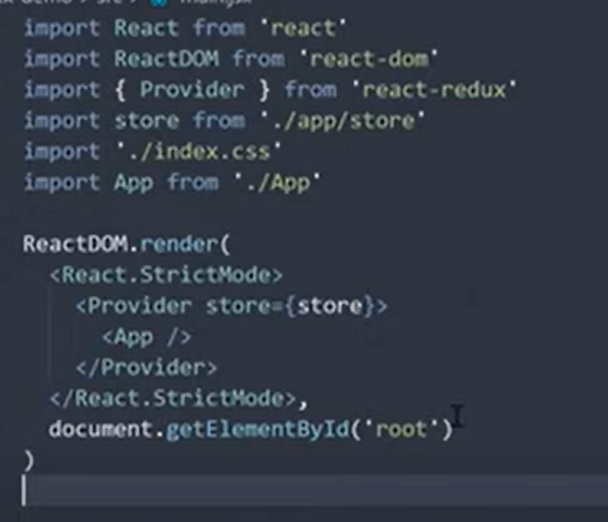

useSelector

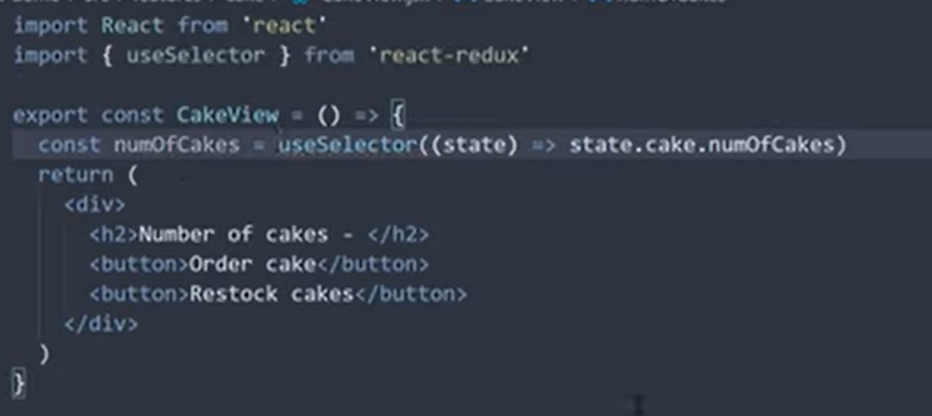

useDispatch

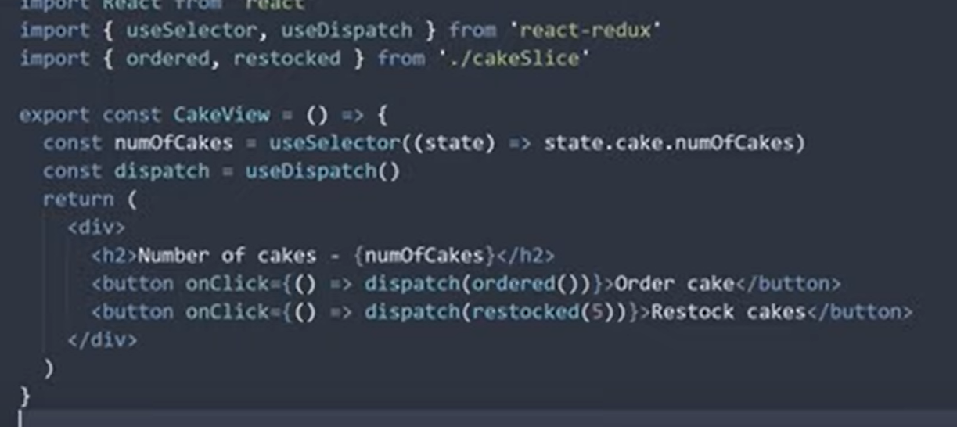

**TypeScript SUpport**

Import PayloadAction from reduxjs/toolkit

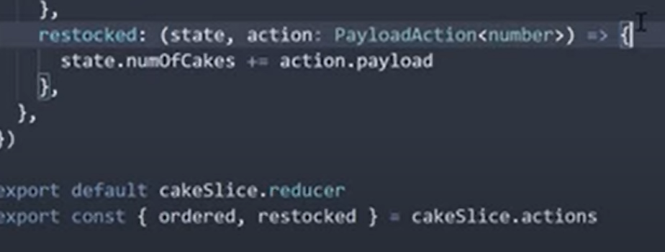

Ensure atleast empty reducer in reduxjs toolkit for createSlice

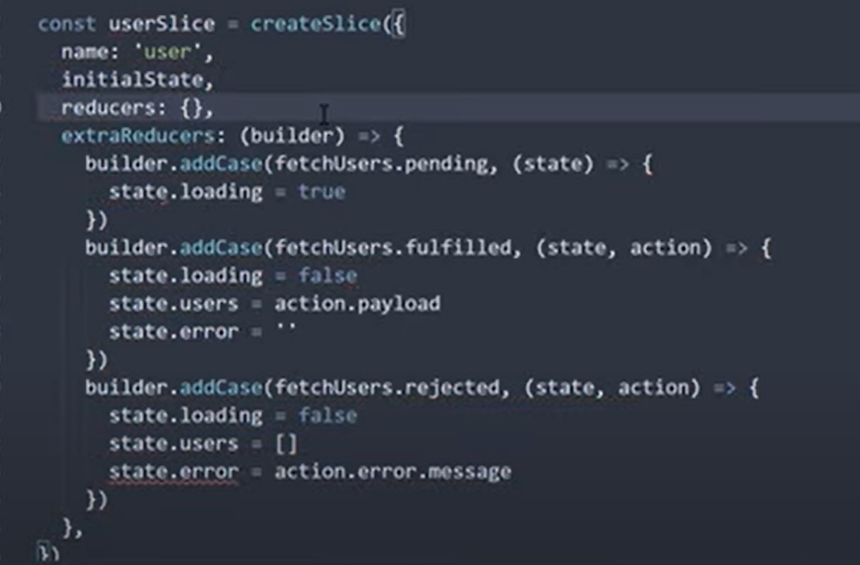

Create root stetae and appdispatch steate

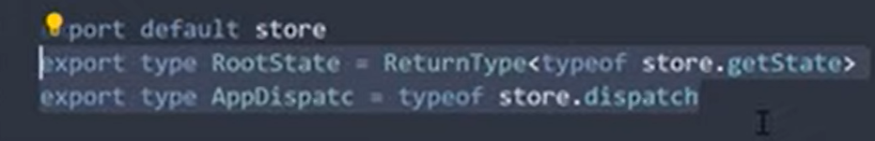

Replace use Selectgor and use Dispaathc with the following to set up easier access thorughout

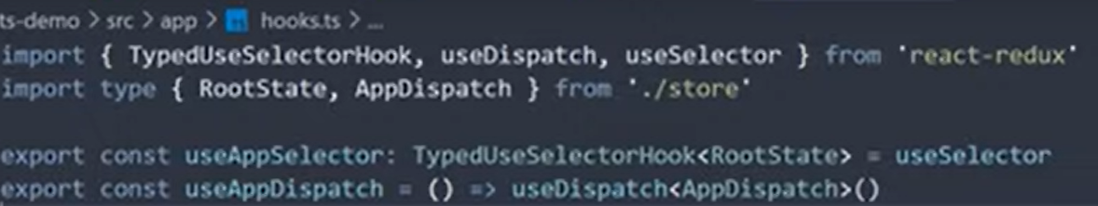

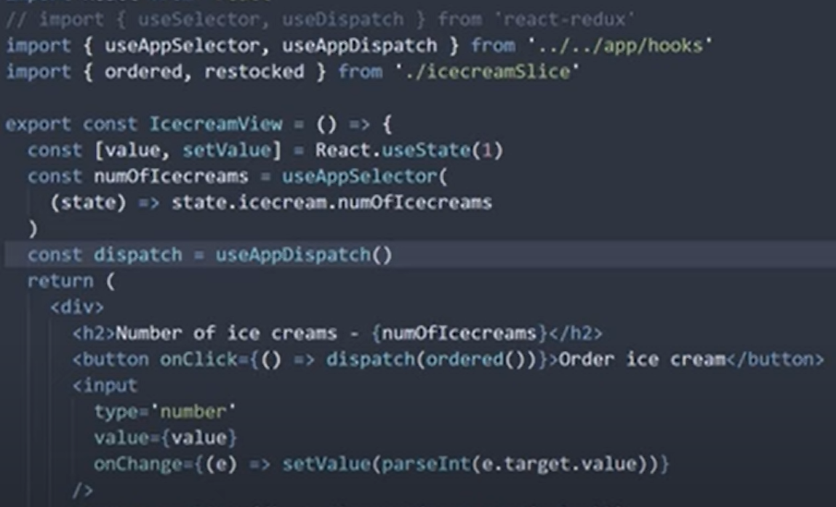

https://codesandbox.io/s/eager-snow-9iddj5